**Battleship in Java**, by Manos Kontakis & Manos Chamilakis  
 2982 3111

As soon as we hit the .jar file, start screen pops up.

At this part, user has two choices. Single Player and Quit.

Four classes involved for the fulfillment of this part of the program.

**Main 🡪 Battleship 🡪 SelectionFrame 🡪 SelectionPanel**

Battleship class handles user selection.

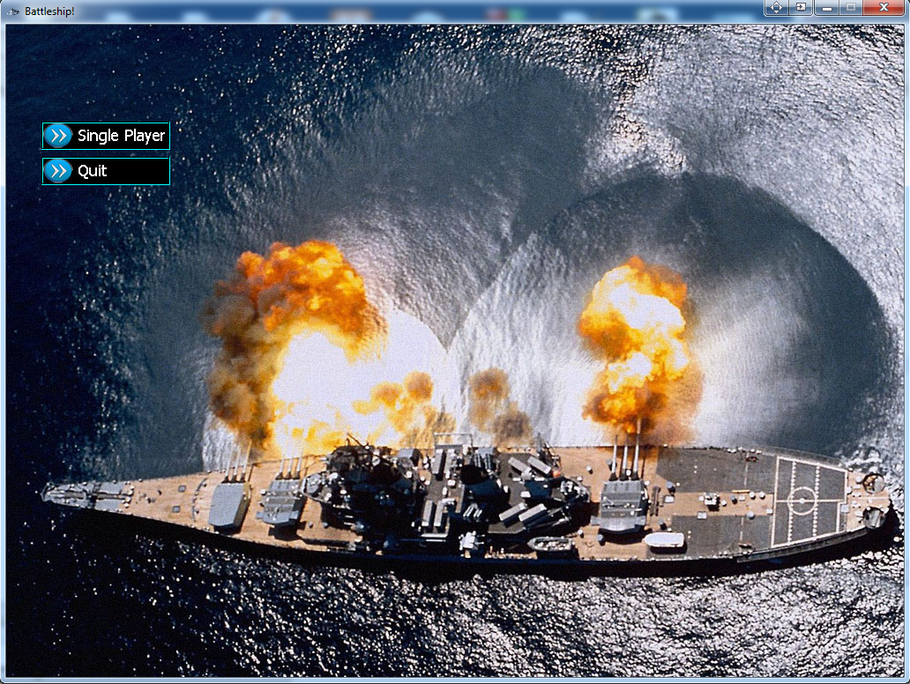

“Single Player” starts the game, “Quit” exits the program.

After Single Player button has been clicked, ship’s placement screen appears, with an   
“Enter Name” pane.

Here, user enters his name

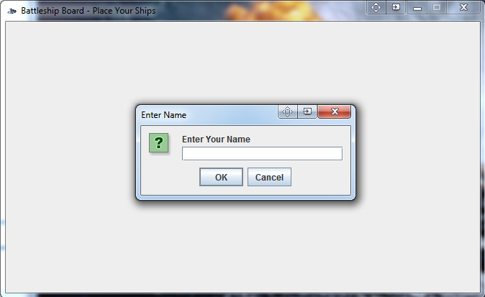

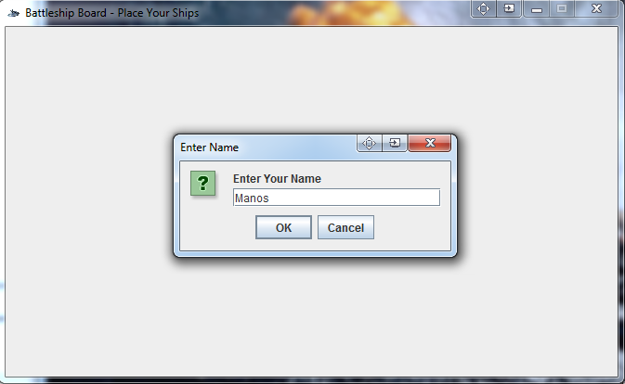

Instantly after user hits OK, user redirects to the placement screen. User must place the ships to his board by clicking the ship and dragging it to the board. Instructions can be found at the right part of the frame.

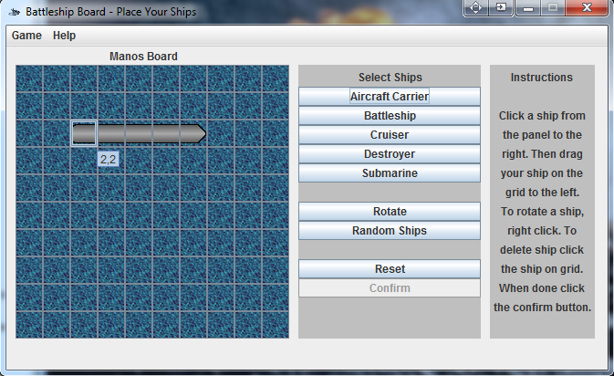

Five classes take place this time:

Menu

Battleship Engine Placement Ship

Computer

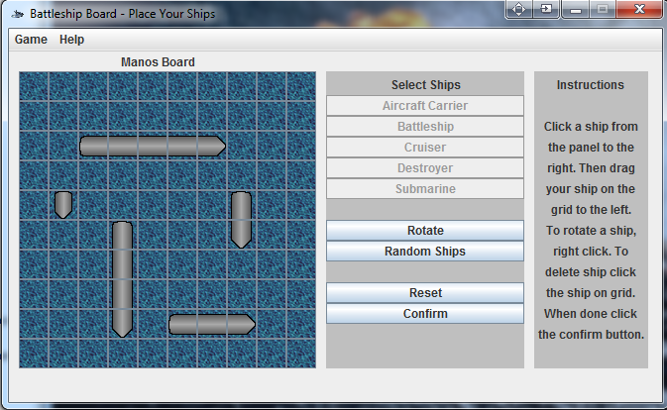After all the ships are placed, Confirm Button becomes active.

Ship formation is done. Battleship is Live!   
This is the part of the game where battleship takes place.  
Player’s Board on the right, with his ships placed and   
Enemy’s Board on the left with its ships hidden.  
Game status on “*Make a move*” can be found on the bottom of the frame.

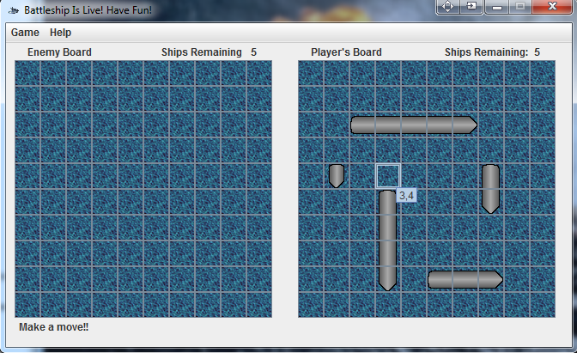

Movements start. Player hits. Enemy follows and hit back. As we can see both player and the enemy missed, so an X-like icon placed on where player and enemy hit.

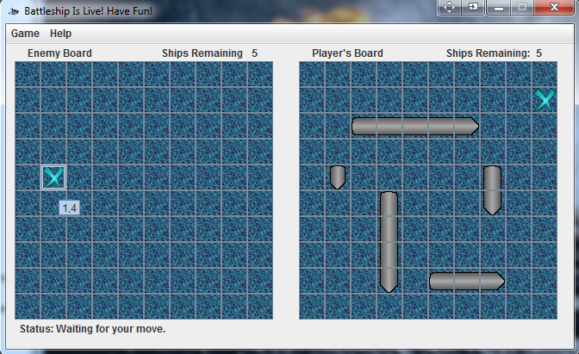

Game continues. We can see that if a shot find its target, a Fire-Like icon is placed. If computer finds target, shrewdly hits neighboring spots*.   
If we hit twice, Game status changes to “*Invalid move, try again*”.

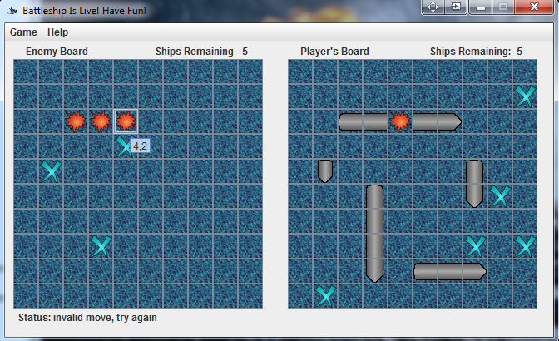

1. Artificial Intelligence (AI) was found on the web and it has been adjusted to our program.

Game proceeds. If player or enemy sink a ship, this area paint red, at the shape of the ship.  
On the top right of each board, we can see the Ships Remaining of each player.

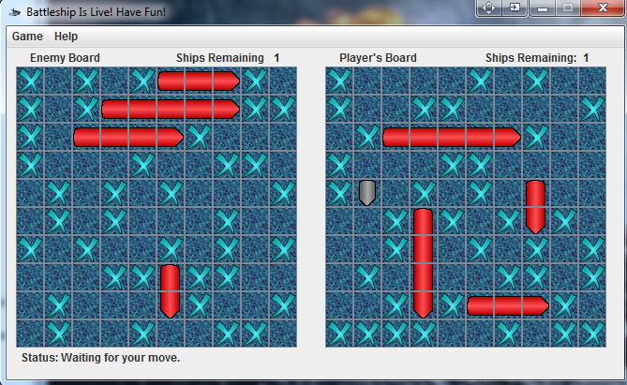

When someone’s ships remaining reach to zero, game ends and a message pops up on the screen.  
“*You Lost*” if you lost (Screenshot below) or “*You Win*” if you win.

During the procedure the classes below are getting involved:

Playboard Ship

Engine   
 Computer

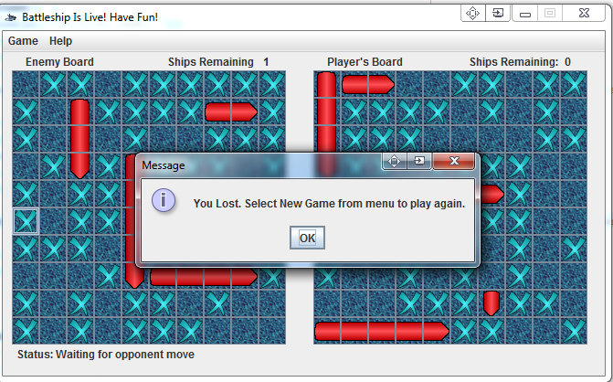

To play again, user can hit Game 🡪 New Game from the Menubar

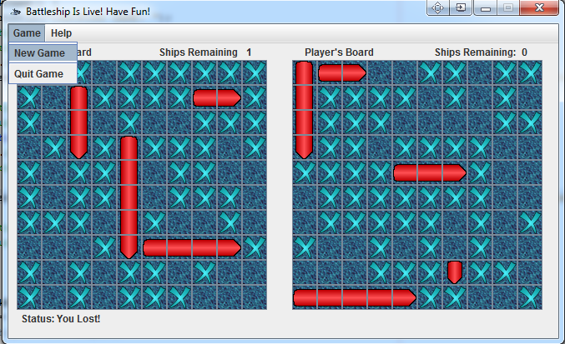

Εικόνα

**EOF**